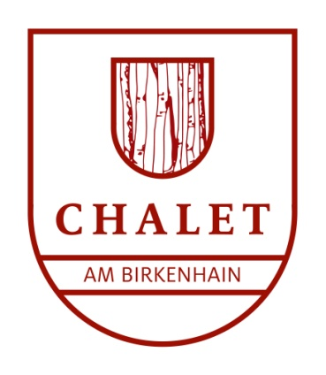

Press release
Beatrice Davis
Telephone: +49 (0)7652 9196151
E-mail: info@ferienresort-am-mattenweg.de

Birkenhain Chalet –
An exclusive retreat located in the heart of the Black Forest

Hinterzarten, 1 January 2019 – The Birkenhain Chalet was built in 1925 in Hinterzarten by a family from Freiburg so they could enjoy the summer freshness afforded by the Black Forest. Since its complete renovation last year, the chalet is now available to guests for vacation rental.

All authentic components of the house have been retained in the interior or, in some cases, retrieved and refitted – for example, the original doors from 1925 and the alcove beds that had been discarded to gather dust over many years in a barn. The beds have also been decorated with exclusive material from the Scottish company Voyage Maison (www.voyagedecoration.com) and colourful textiles from Laura Ashley in England (www.lauraashley.com).

The centrepiece of the chalet is the comfortable parlour with its traditional Black Forest tiled stove. Premium-quality materials from the Austrian company Fine (www.fine.at) combining the local rustic style and modern design are used to great effect here. The furnishing likewise exhibits a tasteful blend of tradition and the latest trends in interior design. Antiques and designer furniture have been assembled with great attention to detail, the combination of which has its own particular charm.
The chalet offers space for up to eight guests. There are four bedrooms, a large bathroom furnished with exquisite accessories from Walther Decor, an additional smaller bathroom, a kitchen, and a small hallway with a cast-iron stove. A further highlight is a separate sauna with its own bathroom and relaxation room.

The chalet is located in a large garden measuring 1000 square metres and features a number of peaceful secluded sites. The garden furniture and pots were manufactured by the Italian company Unopiù (www.unopiu.com).

The Birkenhain Chalet is the ideal retreat to explore and enjoy the Black Forest in beautiful and absolutely authentic surroundings. The chalet also has a claim to some TV fame: it featured in a successful television series in the 1980s – ‘The Black Forest Clinic’.

The Chalet am Birkenhain / Birkenhain Chalet belongs to the holiday resort Am Mattenweg in Hinterzarten.
Available from €230 per night (for two persons); €50 per night for each additional adult, €25 per night for each child.
Reservations can be made by telephone at +49 (0)7652 9196151 or via the internet at www.chalet-schwarzwald.de or www.ferienresort-am-mattenweg.de.

For any further information, please contact Beatrice Davis by telephone at +49 (0)7652 9196151 or send an e-mail to info@ferienresort-am-mattenweg.de.

